**LINUX DEVELOPMENT TOOLS- MAKE FILE**

1. Copy the files below to your working directory. Create the project directory structure and copy them to appropriate directory. Add a makefile in make directory. Compile and generate the executable.

program.c

simplelink.h

simplelink.c

Follow the steps below to create executable.

1. Create the directory tree and keep the .c and .h file in appropriate directories.

2. Create a makefile in make directory with macros, clean and all targets.

3. Run command below from make directory and check the statements for correctness. Check for executable in prj/bin.

make -n all

4. Run cmd below. What did you observe and why?

make clean

5. Run make and generate the executable. Check in prj/bin.

make

6. Run command below.

make clean

7. Run comand below to generate the executable.

make all

8. Make any one line change in source file, try the following command and observe.

make all

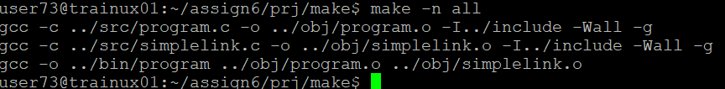



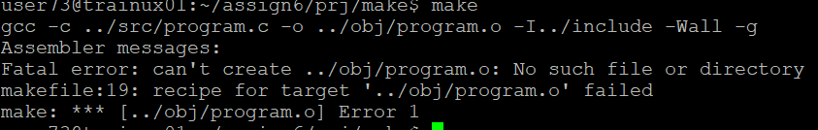

2. Copy the code from directory “prj3_c” to your local working directory.

Compile the code and generate the exe using makefile. [The existing makefile has errors which are to be fixed].

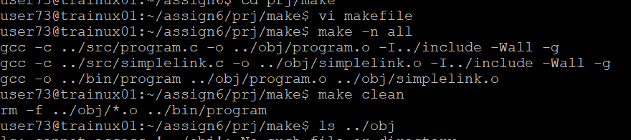

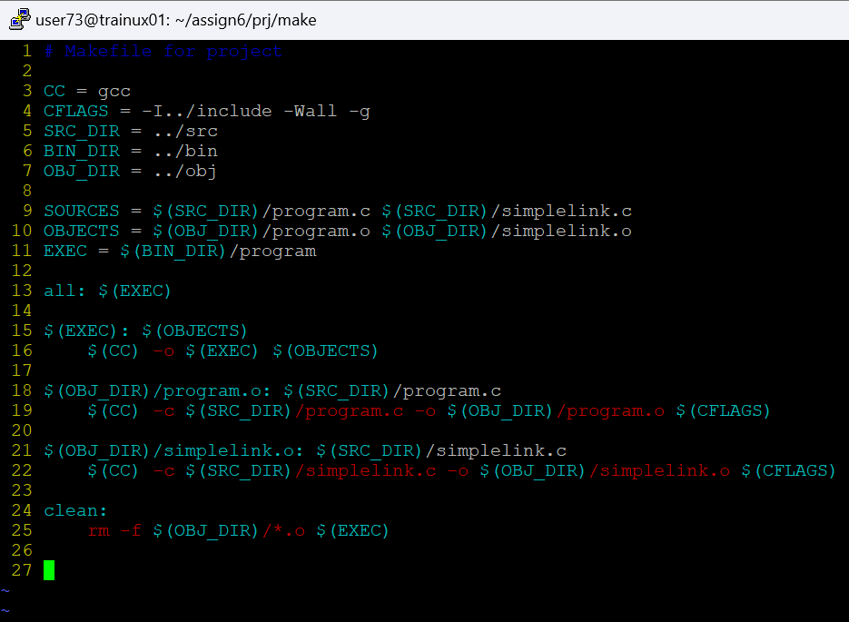

3. Copy the code from directory “prj4_c” to your local working directory. In this code all files (*.c. *.h) are placed in src directory. Do place them in appropriate directory, update the makefile, compile and generate the exe using makefile.

